Daily Journal Layout

# Abstract

This project involves the design and development of a responsive Daily Journal Website using only HTML and CSS. The platform allows users to log daily entries, track moods, and view past activities in a clean, visually appealing layout. The website includes a mood indicator system, a CSS-only night mode toggle, and print-friendly styling. It adapts seamlessly across devices, ensuring accessibility and usability. The final outcome is a functional, user-friendly journaling tool that demonstrates the application of core front-end UI/UX design principles.

## Objectives

- Design a user-friendly interface based on modern UI/UX principles.

- Implement a mood tracking system using HTML data attributes and CSS color coding.

- Create a fully responsive layout using Flexbox and media queries.

- Add CSS-only night mode toggle functionality.

- Provide print-friendly styles for offline record-keeping.

# Scope of the Project

- Focused entirely on front-end design and styling.

- No JavaScript or backend integration.

- Designed for desktop, tablet, and mobile devices.

- Built with only HTML5 and CSS3 — no external libraries.

# Tools & Technologies Used

|  |  |
| --- | --- |
| Tool/Technology | Purpose |
| HTML5 | Content structure and semantic markup |
| CSS3 | Styling, layout, and responsive design |
| VS Code | Code editing |
| Chrome DevTools | Testing and debugging |

# HTML Structure Overview

- Semantic tags: <header>, <nav>, <main>, <section>, <footer>

- Sections: Mood legend, Journal entries, Featured post, Footer

- Navigation: Simple link structure for easy section jumping

# CSS Styling Strategy

- Used external stylesheet (style.css)

- Organized CSS with commented sections

- Techniques used: Flexbox, CSS variables for mood colors, media queries for responsiveness, hover effects, and mobile-first design

# Key Features

|  |  |
| --- | --- |
| Feature | Description |
| Responsive Design | Works smoothly across all screen sizes |
| Mood Indicator | Color-coded system for moods (Happy, Sad, Excited, Tired, Neutral) |
| Night Mode | CSS-only dark theme toggle |
| Print-Friendly Layout | Optimized for black-and-white printing |
| Accessible Typography | Readable font sizes and contrast ratios |

# Challenges Faced & Solutions

|  |  |
| --- | --- |
| Challenge | Solution |
| Layout breaking on smaller screens | Applied mobile-first design and media queries |
| Overlapping mood icons | Used Flexbox alignment properties |
| Typography scaling issue | Used relative units (em/rem) instead of fixed pixels |

# Outcome

- Achieved a clean, consistent, and visually engaging front-end layout.  
- All key components function as intended using just HTML and CSS.  
- Learned about layout responsiveness and UI hierarchy in depth.

# Future Enhancements

- Add JavaScript for interactivity (form validation, dynamic content).

- Integrate animations or transitions.

- Backend integration for form submission.

- Theme toggler (light/dark mode).

## Sample Code

CSS Mood Colors & Night Mode Toggle:

.mood-item[data-mood="happy"] {

--mood-color: #4caf50;

}

.journal-entry[data-mood="sad"] {

--mood-color: #2196f3;

}

#night-toggle:checked ~ .container {

background-color: #1e1e1e;

color: #eee;

}

Print Styles:

@media print {

body { background: #fff !important; color: #000 !important; }

}

# Sample Output

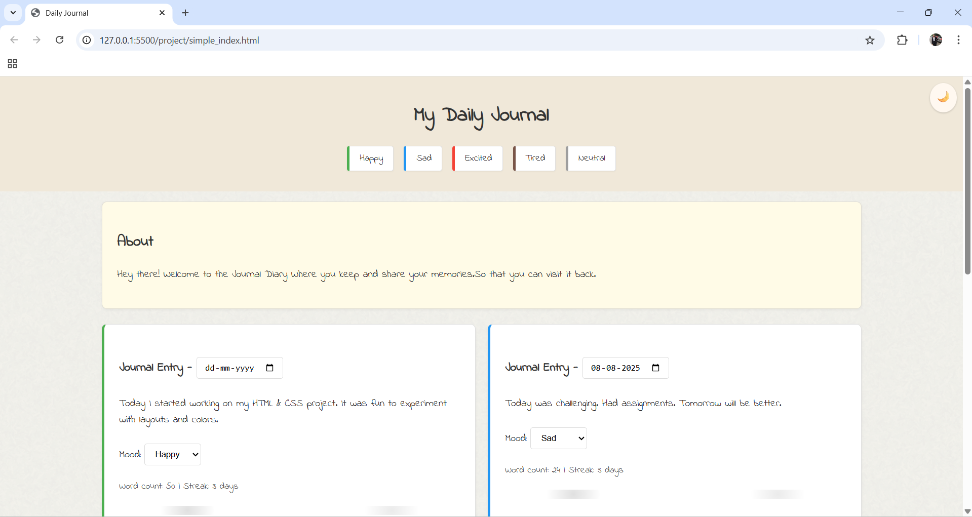

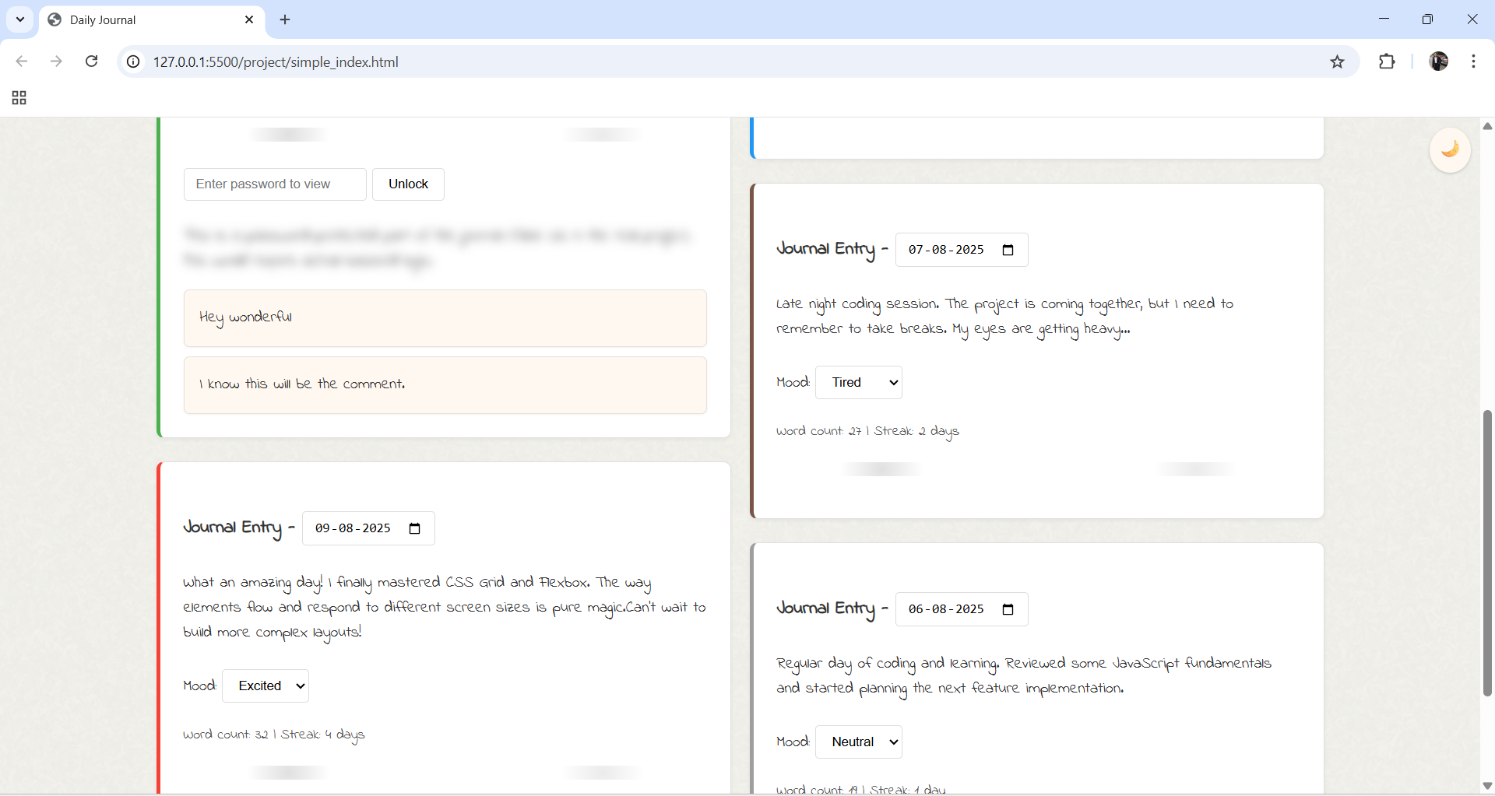

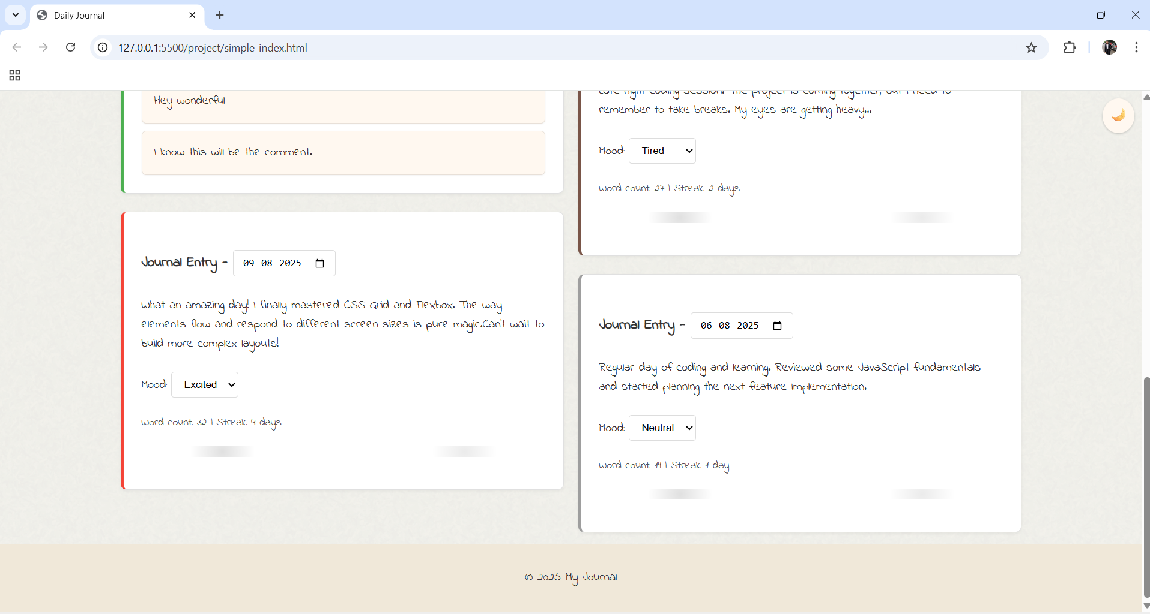

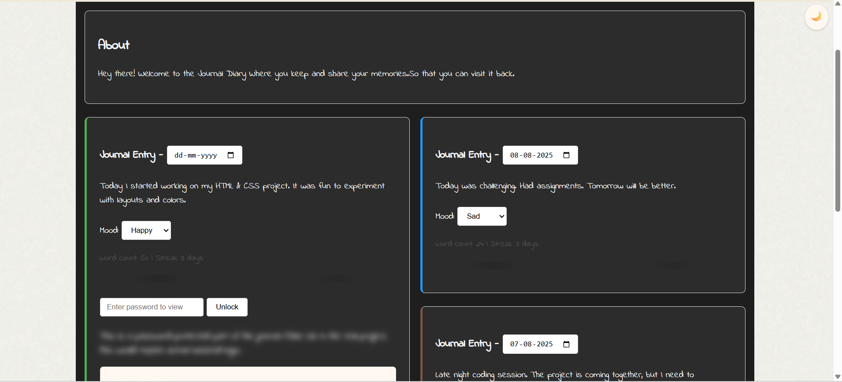

# Conclusion

This Daily Journal Website showcases a clean, responsive, and accessible UI built solely with HTML and CSS. The project strengthened my understanding of front-end development, responsive design, and user interface aesthetics. The implementation reinforced the importance of semantic HTML and organized CSS in building user-friendly web applications.

# References

L&T LMS: https://learn.lntedutech.com/Landing/MyCourse